

**CS/CE 4337 - Assignment#4 Due Date: 11/10/19, 11:59 pm**

*Commented version of code in subfolder

*All codes are ran usingthe **on-line compiler**

1. Using Donald Trump’s family tree, write a prolog program ( a collection of facts and rules) to answer the following queries about the relationships within Donald trump’s family tree.
   * 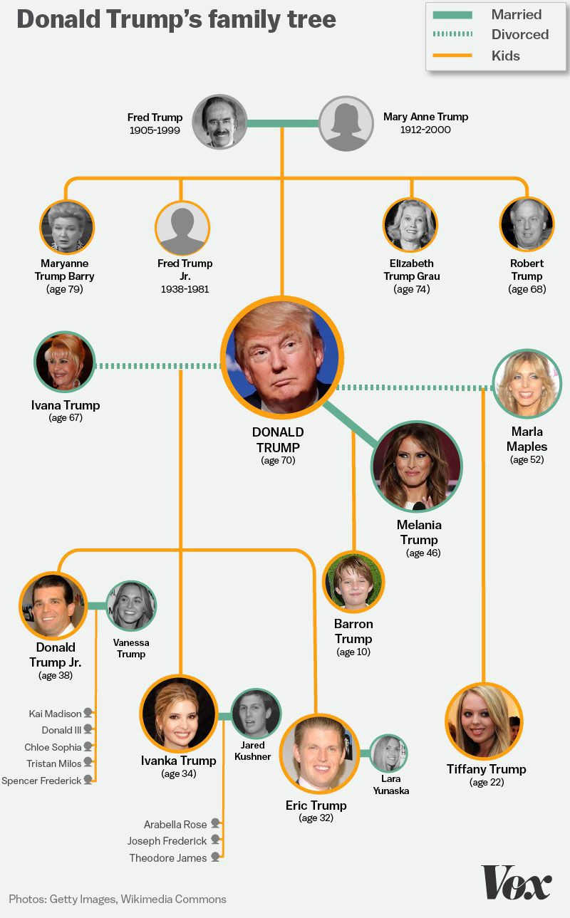Who is the mother of Ivanka trump
   * Who is the step mother of Ivanka trump
   * Who is the father of Ivanka trump
   * Who is the spouse of Donald trump
   * Who is the ex-spouse of Donald trump
   * Who is the sister of Ivanka trump
   * Who is the step sister of Barron trump
   * Who is the brother of Ivanka trump
   * Who is the step brother of Ivanka trump
   * Who is the grandfather of Ivanka trump
   * Who is the grandmother of Ivanka trump
   * Who is the great grandfather of a Theodore James

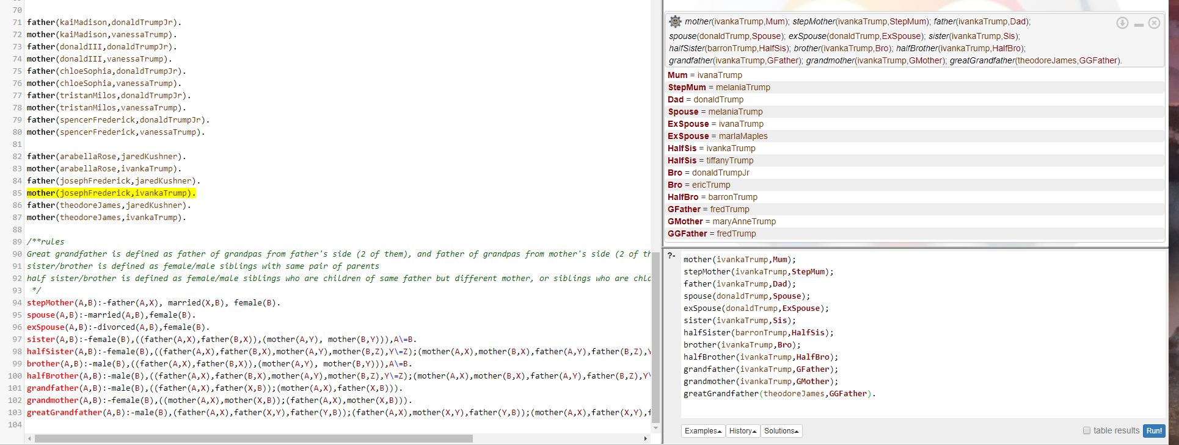

Following picture shows evaluation for sister of Ivanka Trump.

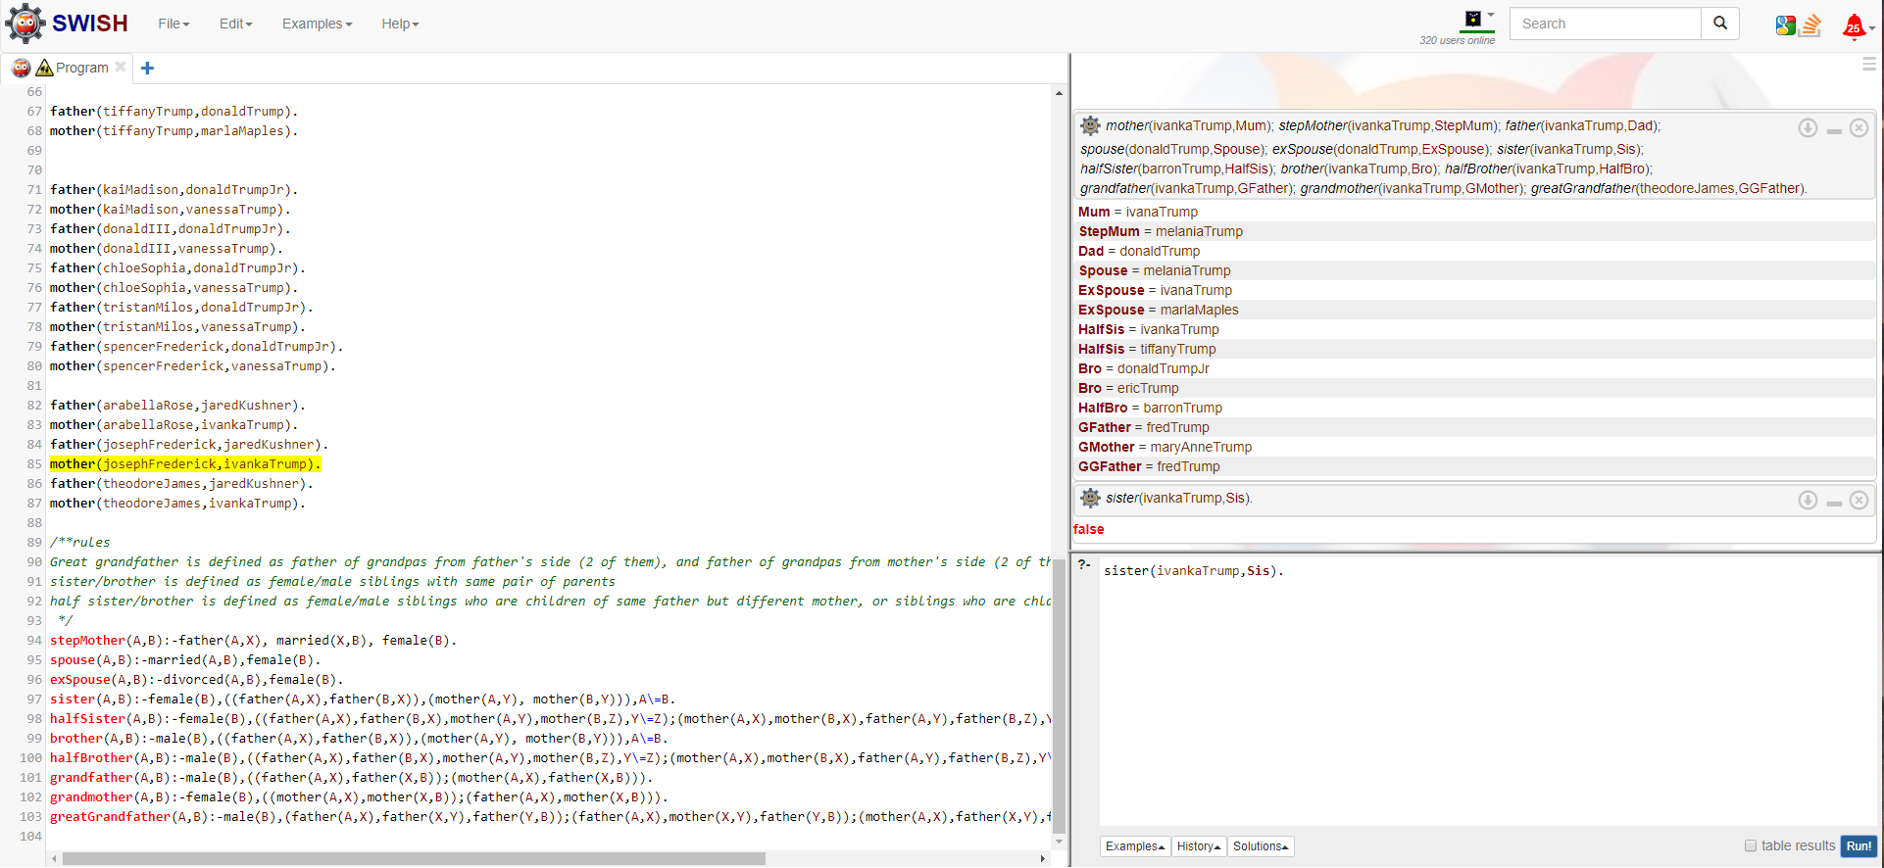

1. Write a prolog program to get a list and append the list to its revered list . For example

?- reverseandappendlist([a,b,c,d],Q).

Q = [a,b,c,d,d,c,b,a]

Please also show the tracing model for the above example

Tracing model:

(1)Call: (1) reverseandappendlist([a, b, c, d], Q) ?

(2)Call: (2) rev([a, b, c, d], R) ?

(3)Call: (3) reverse([a, b, c, d], [ ], Result) ?

(4)Call: (4) reverse([b, c, d], [a], Result) ?

(5)Call: (5) reverse([c, d], [b, a], Result) ?

(6)Call: (6) reverse([d], [c, b, a], Result) ?

(7)Call: (7) reverse([ ], [d, c, b, a], Result) ?

(7)Exit: (7) reverse([ ], [d, c, b, a], [d, c, b, a]) ?

(6)Exit: (6) reverse([d], [c, b, a], [d, c, b, a]) ?

(5)Exit: (5) reverse([c, d], [b, a], [d, c, b, a]) ?

(4)Exit: (4) reverse([b, c, d], [a], [d, c, b, a]) ?

(3)Exit: (3) reverse([a, b, c, d], [ ], [d, c, b, a]) ?

(2)Exit: (2) rev([a, b, c, d], [d, c, b, a]) ?

(2)Call: (2) append([a, b, c, d], [d, c, b, a], List_3) ?

(3)Call: (3) append([b, c, d], [d, c, b, a], List_3) ?

(4)Call: (4) append([c, d], [d, c, b, a], List_3) ?

(5)Call: (5) append([d], [d, c, b, a], List_3) ?

(6)Call: (6) append([ ], [d, c, b, a], List_3) ?

(6)Exit: (6) append([ ], [d, c, b, a], [d, c, b, a]) ?

(5)Exit: (5) append([d], [d, c, b, a], [d, d, c, b, a]) ?

(4)Exit: (4) append([c, d], [d, c, b, a], [c, d, d, c, b, a]) ?

(3)Exit: (3) append([b, c, d], [d, c, b, a], [b, c, d, d, c, b, a]) ?

(2)Exit: (2) append([a, b, c, d], [d, c, b, a], [a, b, c, d, d, c, b, a]) ?

(1)Exit: (1) reverseandappendlist([a, b, c, d], [a, b, c, d, d, c, b, a]) ?

Q = [a,b,c,d,d,c,b,a]

yes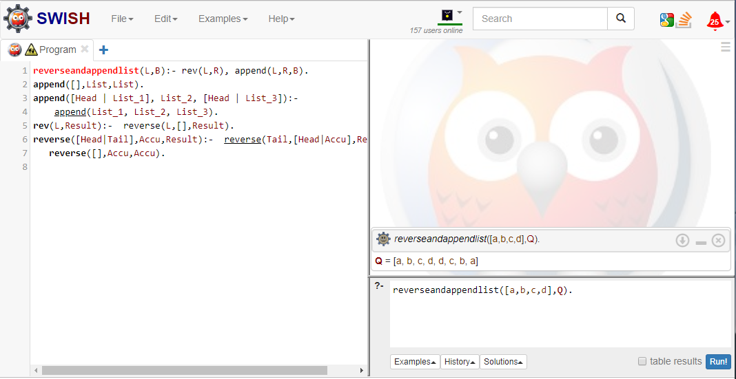

1. Write a prolog program to get a list and return the number of elements in the list. For example

?- nelements([b, [a, [d, c], e]], Q). Q = 5

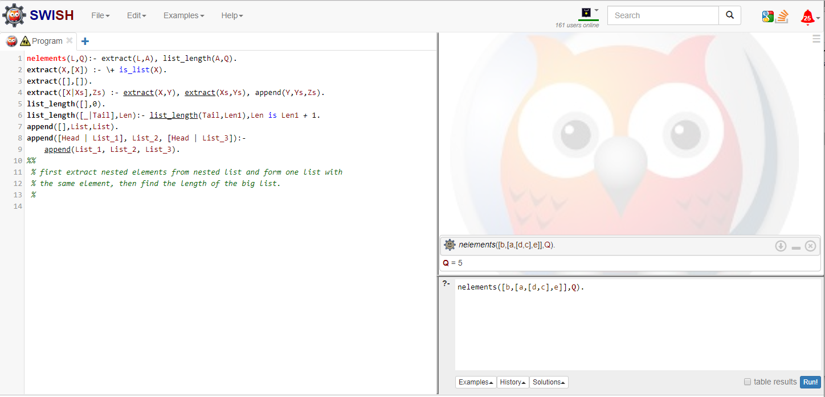

1. Write a prolog program to get a list and delete the first three elements of a list and the last element of the list and returns the list without those elements

For example

?- delements([a,b,c,d,e,f], Q). Q = [d,e]

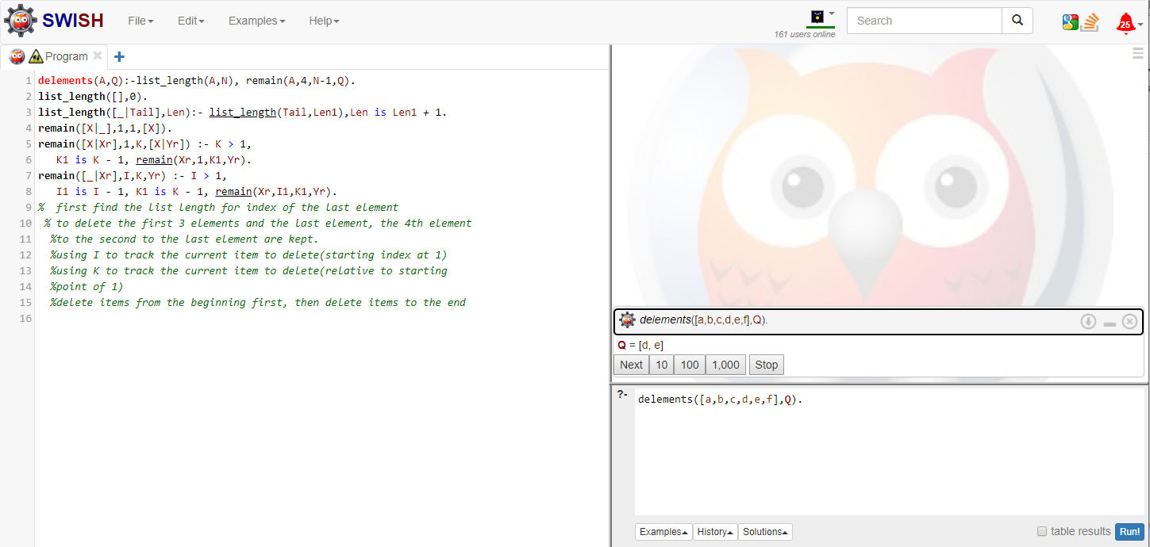

1. 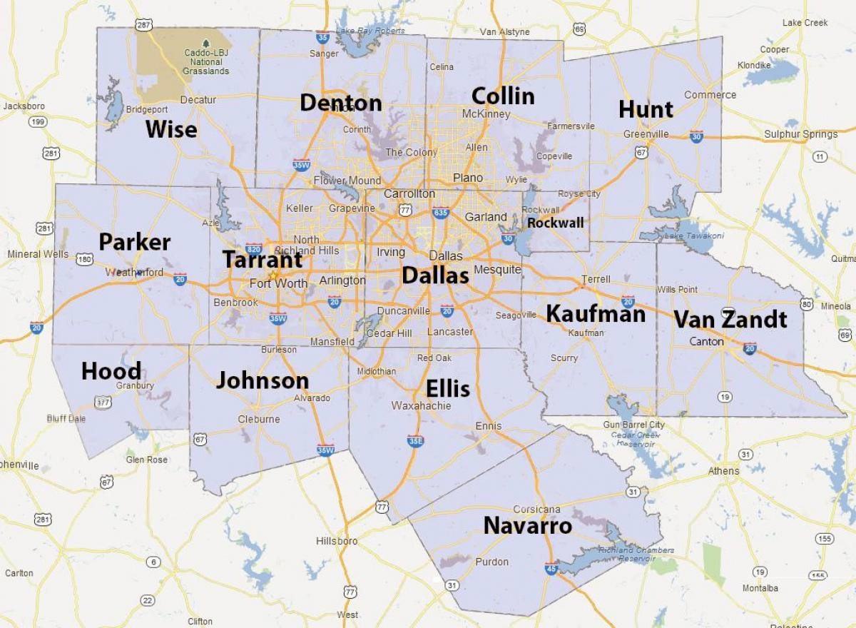The following picture shows DFW Counties. Write a prolog program to find all acceptable coloring of DFW map such that all adjacent Counties have different colors. Your program should color the map using minimum num- ber of colors.

Minimum number of color used: 3

Total coloring ways: 12.

Query used:

regionColor(Wise,Denton,Collin,Hunt,Parker,Tarrant,Dallas,Kaufman,Rockwall,VanZandt,Hood,Johnson,Ellis,Navarro);

aggregate_all(count,regionColor(Wise,Denton,Collin,Hunt,Parker,Tarrant,Dallas,Kaufman,Rockwall,VanZandt,Hood,Johnson,Ellis,Navarro),Count).

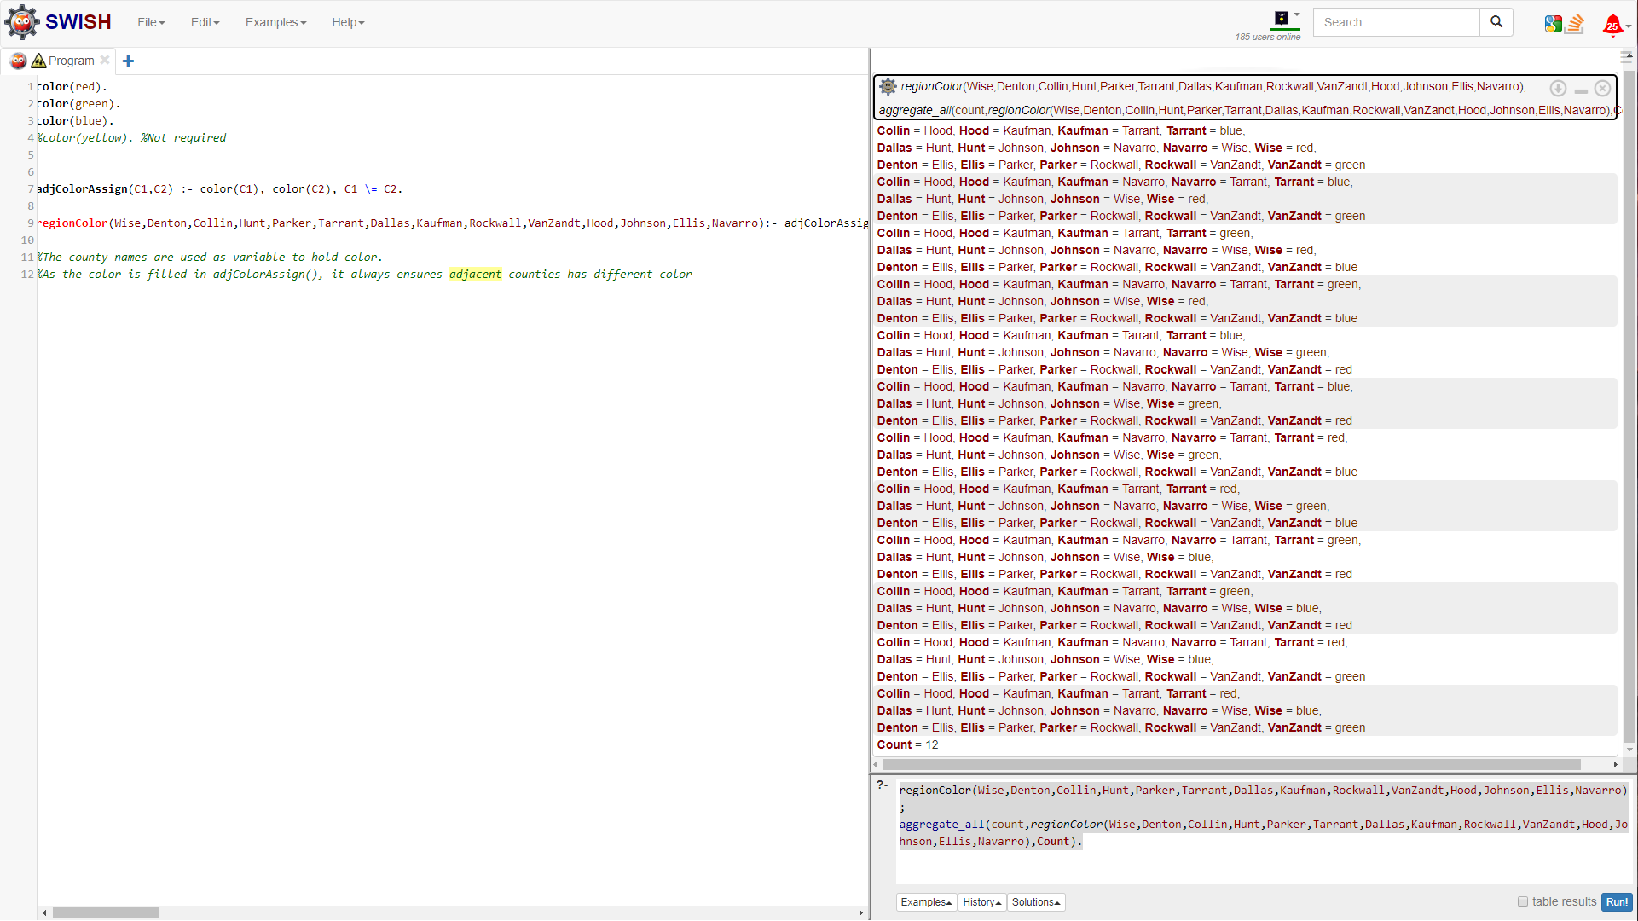

1. The following table shows the population and Median household income of Dallas County, Collin County, Denton County, and Tarrant County on 2018.

|  |  |  |
| --- | --- | --- |
|  | **Population** | **Median Household Income** |
| **Dallas** | 2600000 | 60000 |
| **Denton** | 850000 | 65000 |
| **Collin** | 1000000 | 90000 |
| **Tarrant** | 2000000 | 62000 |

Using above information, Write a prolog program to answer the following queries

* Is Dallas County the neighbor of Tarrant County?
  + neighbor(dallas,tarrant)
* Which counties are the neighbors of Dallas County?
  + neighbor(dallas,A).
* Is there a neighbor of Dallas County that has a smaller population than Dallas County? Which one?
  + smallPop(B,dallas).
* Is there a neighbor of Dallas County that has a smaller population and higher median income than Dallas County? Which one?
  + smallPopHighin(C,dallas).
* Is there a neighbor of Dallas County that has a smaller population and lower median income than Dallas County? Which one?
  + smallPopLowin(D,dallas).
* Which county does have the largest population?
  + largestPop(Q).

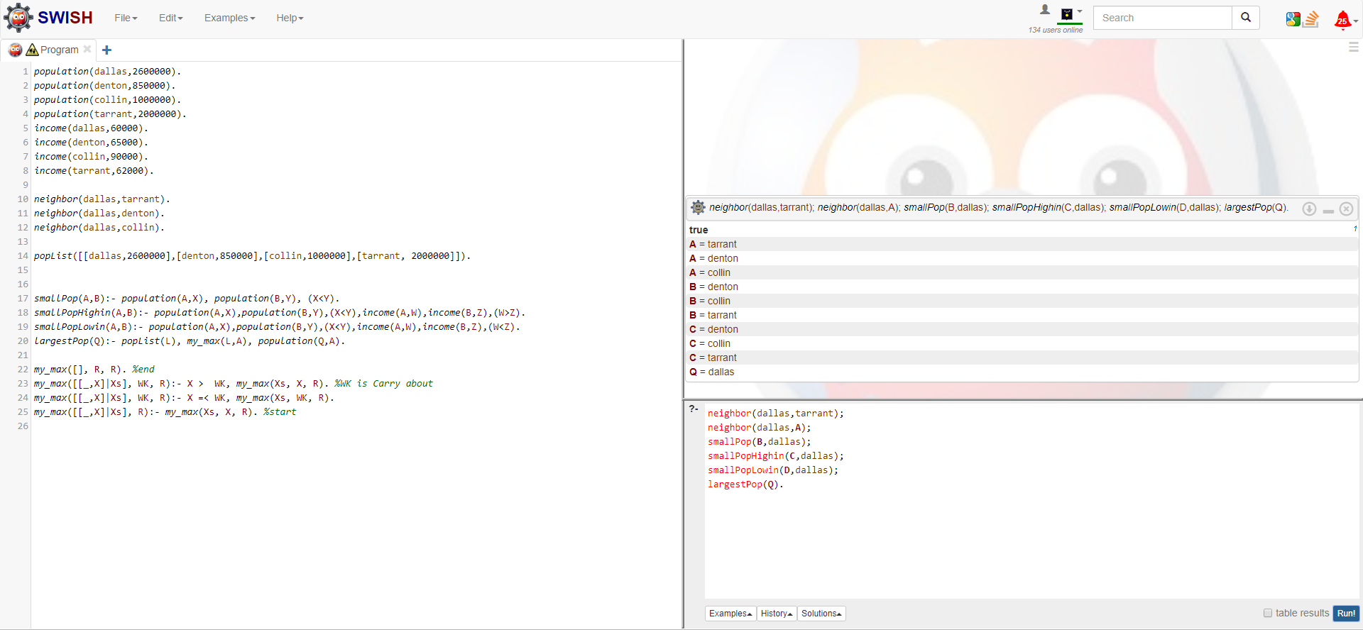

1. Write a prolog program representing the following flight network. Each node denotes an airport-city with its corresponding tax and minimum security delay. Each link denotes a flight and is labelled with its corresponding airline name, price, and duration. You should change any names to lower-case letters and re- move spaces in name.

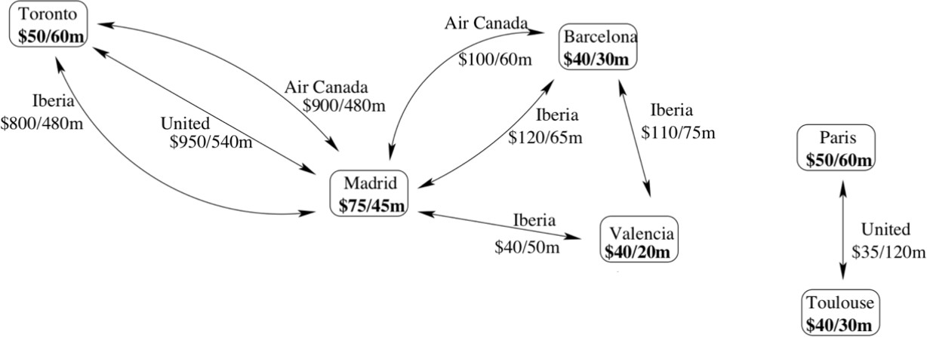

* Write a query to show tax and minimum security delay for Madrid airport-city
  + madridAirport([MadridTax,MadridDelay]).
* Write a query to tell us if there is a flight from Toronto and Madrid ( yes or no)
  + flight(toronto,madrid).
* Write a query to show the airline name, price, and the duration of all the flights from Madrid to Toronto
  + madridTorontoRoute([Airline1,TotalPriceOfAirline1,TotalDurationOfAirline1],[Airline2,TotalPriceOfAirline2,TotalDurationOfAirline2],[Airline3,TotalPriceOfAirline3,TotalDurationOfAirline3]).

